Hay Writers’ Circle
Richard Booth Prize 2026 for Non-Fiction

Please follow the guidelines below if you would like to enter.
You can contact writers4haycomp@gmail.com if you have any questions or queries.

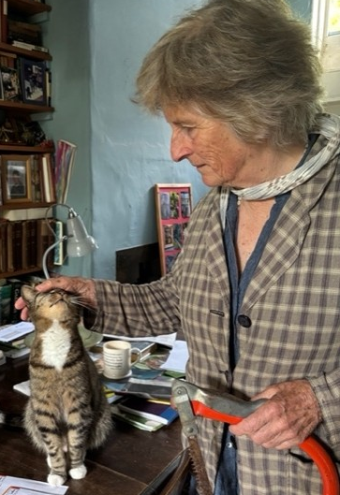
Our Judge this year is Ruth Pavey

Ruth is a journalist, teacher, naturalist and author of two books: A Wood of One’s Own (a Sunday Times Book of the Year), and Deeper into the Woods, which relate her struggle to rescue derelict woodland in deepest Somerset.

As a writer late to publication, she admires everyone who writes from the heart and doesn’t give up…

Criteria
- Entries must be written in English and entirely the work of the entrant and by submitting you are confirming that the work is your own. Minimum word count 500; maximum word count 1250. AI-generated work is prohibited. Any evidence to the contrary will result in immediate disqualification.
- Entries must not have been published, self-published, published on any website, blog, social media, or online forum, broadcast nor winning or placed (as in 2nd, 3rd, runner up etc.) in any other competition.
- If your entry has been long-listed or shortlisted in other competitions and provided it has not won a prize or been published, it is eligible.
Cont.

- Simultaneous submissions are allowed but will become ineligible should they win a prize elsewhere or be published prior to the date of prize giving. Entry fees will not be refunded. You must inform us immediately should your entry be published or win a prize elsewhere.
- Entries submitted posthumously are not eligible.
- We will disqualify entries if they are named or over the word limit. If you forget to add the title or word count your entry will NOT be disqualified.
- Alterations cannot be made to entries once entered, so please ensure you send the correct version. You are advised to keep a copy of your work.
- The closing date for entries is 23.59 GMT, Tuesday 7th July 2026 . Any entries received after this date will not be considered.
- The judge’s decision is final.
Entries
- Please use a good-sized text (12pt preferred), clear typeface (e.g., Times New Roman, Arial, or Courier) and double spacing, as a courtesy to our judge.
- All entries are judged anonymously. Your name or any contact details must NOT appear on your entry. Please put your name, title, and contact details on the booking form only. Please do not include your name in the file name.
- Please put the title and word count at the beginning of your entry. Please number your pages and secure them together if you are submitting a hard copy.
- We would prefer entries via email but will also accept hard copies.
- Via email: Send your entry to writers4haycomp@gmail.com as a word document attachment or PDF, with a completed copy of the form overleaf attached. Please write ‘competition entry’ in the subject box.
- Via post: Send your printed entry to - The HWC Competition Secretary, 4 Cwrt-y-Camden, Brecon, Powys, LD3 7RR with a completed copy of the form overleaf attached.

Cont.
Payment
- Entry fee is £5 for one entry per person. Please pay by BACS payment and ensure that your payment is received, with your name on the reference, before 23.59 GMT on Tuesday 7th July. Cheques will not be accepted. First prize is £50, second prize is £25, and third prize is £10.
- UK Entries - BACS payment can be made to:
Hay and District Writers’ Circle, NatWest Bank,
Sort code 53-50-31, Account no. 52557499.
- We welcome international entries in the English language.
Please pay via IBAN: GB72NWBK53503152557499 - BIC: NWBKGB2L
Please use your name as the reference on all payments.

Results
- The results will be announced September 2026. Results are final and correspondence will not be entered into over the results.
- Winners will be notified and results posted on our website.
- At our discretion, the winning entry will be published on the Hay Writers’ Circle website with the winner’s consent. Publication may prevent eligibility for other competitions. All rights remain with the author.

HAY WRITERS’ CIRCLE COMPETITION BOOKING FORM

Competition
Title of entry
Word count
Name
Address
Telephone
Email
Updates | If you would like to be kept up to date with all our news, future events, workshops and competitions, please go to our website, www.haywriters.com and subscribe using your email address.

